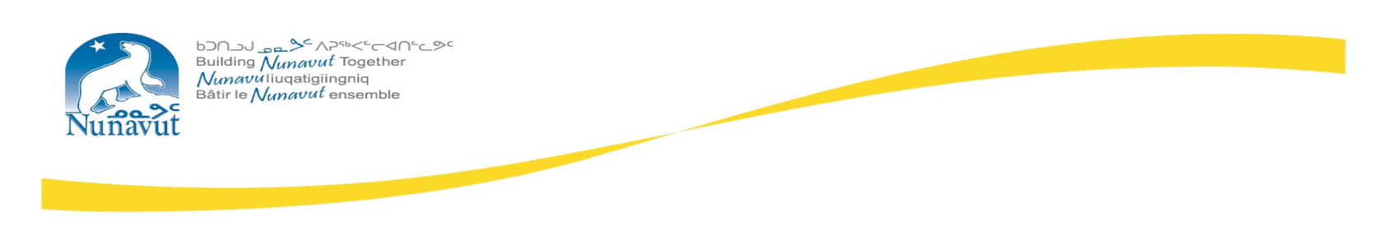
NUNAVUT KAVAMANGANI HAVAAKHAQ
ᐋᓐᓂᐊᖃᕐᓇᙱᑦᑐᓕᕆᔨᒃᑯᑦ
Munarhilliqiyikkut
HAVAGVIAT MUNAQHILIQIYITKUT
HAVAKTULIQIYIKKUT HAVAKTIT
MINISTÈRE DE LA SANTÉ

Nunallaami Munaqhi
Havagviat Munaqhiliqiyitkut
Nunallaani: Sanirajak

Takuyaqtuqlutit Kanatapta ukiuqtaqtumi avatanik. Aghalliaqaqtuq alianaqtunik, tatqiagikhivakltuqlu, autiqaqtuqlu ukiuriktuqlu nunani. Ihuaqutauyut hivituyut ukiungani unnuat, upingakhamilu,auyamilu qaumalirangat 24-ni ikarnirni, tingmidjatlu tingmilirangata, atlangayutlu niryutit piniqpiaktutlu nauttiat.

Nunallaami Aanniaqtuliriyitkut Munaqhit havaariyaa angiyumik nunallaami aanniartunut havakpakhuni havaqatigiplugit munarihiliqivingmi havaktiit munaqhillu. Aanniaqtut takuuqtauvaktut inungmik,ilagiiktunik, uvaluuniit nunallaat. Nunallaami munarhi ikayuqpaktut inungnik kangiqhipkainikkut, aanniartailinirmut ihuarhaivlutiklu nakuuhipkaivlutiklu aanniartailidjutikhanullu aanniarutinit, ayuqhautinut tuquyunullu. Havakpiaklutik ikayuutigilugillu aanniartailidjutikhanut pidjutauyuq aanniartailidjutikhanut inungnut nunallaamullu. Havaarivagait ayuittiaqhimavlutik nunallaami munarhivlutik aanniartunik pivagait malikhugit atuqtakhanut maliktakhautiliuqhimayunut munarhiliqinikkut, inuuhiudjutikhat havaktauyakhallu munarhiliqiyitkunit.

Umunga havaakhamut apiqhuqtauyumaguvit , havaakhakhiuqtuq pihimayaqaqtukhauyuq:

- Bachelors-nut naunaitkutikhaq titiraq Munarhiliqinikkut unaluunniit Munarhiuyunut Titiraq Naunaitkutikhaq piqaqluni Inungnik Munarhiliqinikkut Titiraq Naunaitkutikhaq ilitariyauhimayunikluunniit ayuiqhayaminik, ayuikhattiarutikhanut ayuikhayakhaq, aadjikkutaanut munarhiuvaktunik unalu nunallaami munarhiliqivingmi munarhiuhimayunut.
- Havaarittaaqlugit ayuittiaqhimayumik munarhiuluni (ukunatut miqhurnikkut, timimut qiqtaliqhirnikkut) havaktakhanut naunaiqhimayunut talvani Munarhiliqiyikkut, Munarhinut Auladjutikhanut Maliktakhat; Atuqpagainut, Maligat Maliruagakhatlu; Auladjutikhanut Maliktakhat
- Quyadjutikhaqarlunilu aatlanik inuuhiqaqtunik, pitquhiqaqtutlu aktuutauvaktut aanniqtuliriyitkunut, ihuaqhaiyuminakhutiklu atuqtakhamingnik aanniaqtunut munaqhiunikkut atuqtakhamingnik.
- Ilihautjittaaqtukhaq/uqautjilunilu inungmik inugniklu havaktaaktukhaq allatqiiktunik inuhiqaqtuni.
- Uqaqtaarniq inuktitut/inuinnaqtun ikayuutauniaqtuq
- Basic cpr and annual re-certification required to maintain skill level
- Eligible for registration with rnant/nu

Una havaaghaq ilauyuq talvani nunavutmi havaktiit ikayurtingitni. Aullautiqaqtuqlu akiliuhianganik -$99,743-$113,159 atauhiqmi ukiumi umingalu ukiuqtaqtumi akiliuhiangani atauhiqmi ukiumi $23, 561.00 nalliani nunaqaqtuni. Iglukhaqarnia: akikhilaakhimayumik iglukhanqaqtuq

Havaaqaqhimmaaqtut munakhit, havaktukhaqhiuktit manikhangita ilatjutikhat: $5,000-mik havaakhaniktitautjunmini, $5,000-mik 18-ni tatqighiutit naatpata havaakhanikvini $10,000-mik 30-ni tatqighiutit naatpata havaakhanikvini. maniktaqvikhangit ilaliutiyukhat akiliuhiakhanut hammauyut $9,000 - $19,500 nani nunaqautaani imatutlu havaakhimmaaqqat (0-5 ukiuni) $375 akiliqtauniaqtuq tatqighiunmi tamaat.

Naunaitkutaa #:10-02-225-094LA Umigvikhaq Ublua: Angmaumaniaqtuq havaktukhanikpat

